**Boys & Girls Club**

**of Bangor**

**Parent Handbook**

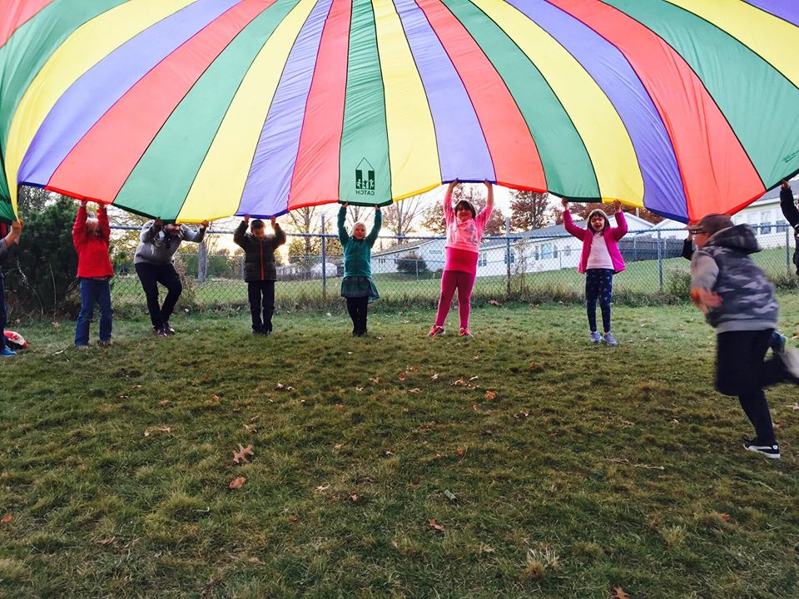

Mission Statement:

***To enable all young people, especially those who need us most, to reach their full potential as productive, caring, responsible citizens.***



Boys & Girls Club of Bangor

161 Davis Road, Bangor, ME 04401

Phone: 207.404.4524 - Fax: 207.942.6043

Director: Catherine “Cat” Myatt

email: [cat@BGCBangor.org](mailto:cat@BGCBangor.org)

[www.bgcbangor.org](http://www.bgcbangor.org)

Welcome to the Boys & Girls Club of Bangor! This Club serves families by providing a quality program for children after school and during the summer. This program offers the opportunity for children to enjoy a safe and warm, child-oriented experience.

This handbook contains information regarding the After-School program. It is very important that you read this handbook and keep it handy as long as your child is enrolled in the program. It will answer many of the questions you have about the Boys & Girls Club. You may also contact program staff at the above phone number, address, or email any time during normal business hours.

**Philosophy and Goals**

The Club will meet the child’s physical, social, and emotional needs. Based upon play and social experiences, the program will compliment, not imitate the school day.

The needs of the children will be met by creating an environment that:

* Provides for the development of self-esteem in selection, structure, and balance of activities offered.
* Offers children a base of warmth and security provided by caring staff, in which they can all grow, respect, and enjoy each other.
* Fosters individuality, decision making, problem solving, and interest exploration.
* Encourages and provides freedom and creativity within set limits.
* Provides nutritious foods that meet the health needs of growing children.

The needs of the parents will be met by a program that:

* Provides security of a safe and caring environment.
* Involves parents in planning, communication and provides accessible parenting information and programs.
* Suggests special services as needed.
* Creates a bridge between school and home hours.

…all at no cost to the family.

The needs of the community will be met by providing a program that

* Provides quality child care services.
* Prevents the development of undesirable behavior patterns by providing constructive activities, skill development, and mentors.
* Shares and builds upon existing resources.
* Recognizes the important contributions of the Boys & Girls Staff.

The Boys and Girls Club is funded by BangorHousing and several other grant contributions. Special mention to **United Way of Eastern Maine** and the **Cole Transportation Museum** for supporting our Club and its members.

**United Way of Eastern Maine** raises funds each year to distribute to agencies that offer health and human services to improve the lives of everyone in our community. The Boys & Girls Club of Bangor is one of over 50 programs and initiatives which benefits from the generous contributions received by United Way of Eastern Maine. The funds we receive allow us to offer programming (including transportation, healthy and nutritious snacks, homework help, and access to amazing mentors) so that every child, regardless of their situation, can walk through our doors and participate in life-changing programs and opportunities!

Generous scholarship funding from the **Cole Land Transportation Museum** has allowed the Boys & Girls Club to open our doors to several additional children, who otherwise might not have been able to attend programming, during the school year and summer months. With this gift, these children and their families will benefit from our outcome-driven Club experience, resulting in academic success, good character and citizenship, and healthy lifestyles.

**Enrollment and Membership**

Membership is required to participate in all Club programs. Completion of the membership application and an annual membership fee of $5.00 is due upon registration. Membership will expire 1 year from the registration date and must be renewed annually in order to continue membership. There will be no refunds of membership fees.

Any changes to the information provided on the registration form must be communicated to the club immediately so that current information is always on file. This is for the safety of your child.

**Attendance Policy**

Members attending the *After-School Program* must attend the Club a minimum of 3 days per week in order to hold their spot. If your child participates in extracurricular activities that might interfere with this policy, please contact the Clubhouse at 404-4524 to discuss an individual plan.

Members attending the *Teen Center Program* must attend the Club a minimum of 2 nights a week in order to hold their spot. If your child participates in extracurricular activities that might interfere with this policy, please contact the Clubhouse at 404-4524 to discuss an individual plan.

**Hours & Days of Operation**

Our club will be open to children Monday through Friday between the hours of3:00pm-5:00pm for grades 1-5; Monday, Wednesday, Friday from 2:30-4:30pm for grades 6-8, and Tuesdays and Thursdays from 2:30-4:30pm for grades 9-12.

Occasionally, there may be other classes or workshops that members may sign up for, such as Film Club, and the dates and times of their meetings will be shared with participants.

The club follows the Bangor School Department calendar. A copy of the 2018-2019 calendar is included in the back of this handbook. The center is closed when schools are closed (scheduled or emergency).

**Parent-to-Staff Communication**

If you need to make changes to your child’s schedule, such as pick-up or drop-off changes, absences, or any general questions, **please call 404-4524 before 2:00 pm.** Staff will do a final voicemail check at 2:00pm to receive any last-minute requests or changes by parents. Communication via text to staff phones will not be accepted.

It is important to our staff to give your children one-on-one time and attention while they are at the Club. Knowing the daily schedules of our members before the program starts, will help our Club run smoothly.

**Pick-up Policy**

*After-School Program:* Parents/guardians are required to pick up their children between 5:00-5:15pm at their designated pick up location. If you need help with transportation, please call the Clubhouse at 404-4524 for special accommodations.

*Teen Center*: Parents/Guardians are required to pick up their children between 5:00-5:15pm at the latest at the Clubhouse. Teen members will be allowed to walk to and from the program once they have turned in a signed *teen center agreement with a parent signature*. If you need help with transportation, please call the Clubhouse at 404-4524 for special accommodations.

**Staff/Child Ratios and Maximum Group Size**

The state maximum for group size is 12 children to one adult for school-age children. There will always be two or three staff members assigned at each site to ensure appropriate supervision. **The maximum number of children in an area at any time will be 24 (exceptions are snack and outdoor play).**

**Daily Schedules**

The Boys & Girls Club offers a variety of activities to enrich the lives of your children. Our three priority outcome areas are: Academic Success, Healthy Lifestyles, and Character and Citizenship. All of our programs will contribute to achieving great results in those focus areas.

Homework: Students will be offered homework assistance during Power Hour. A quiet area will be provided and helpful staff and mentors will be available for members to work on homework assignments. It is important that parents understand that while given a chance to work on homework, all homework might not be completed or corrected within that hour as staff often do not have time to check everyone’s homework thoroughly. It is ultimately the parent’s responsibility to check with their child on all matters dealing with homework and school projects.

Every day members will participate in Power Hour to work on their homework and then break out into their Mini Clubs for the second hour of programming. Members sign up for Mini Clubs on a monthly basis with a variety of choices ranging from additional homework help time to crafts, sports, music, and more.

**Withdrawals**

Parents wishing to withdraw their child(ren) may do so at any time. A one-week notice is appreciated.

**Inclement Weather**

The Club follows the Bangor School Department schedule. When school is canceled due to weather, the Boys and Girls Club will also be closed that day. When school announces an early release, or a half day, the Club will be closed. However, if school is in session, but the after-school activities are canceled, we will remain open but will not provide transportation home. Under those conditions, parents who choose not to have their child attend the club will need to notify the school.

**Transportation Policy**

Transportation will be provided from the Downeast School to the Clubhouse via the Boys & Girls Club bus. Children arriving from the Fairmount School take BUS O and will be dropped off at the gym where a staff member will be waiting. Children arriving from the James F. Doughty School take BUS A and will be dropped off at the Clubhouse.

**Supervision Policy**

A major responsibility of the staff is to ensure the health and safety of each child entrusted in our care. Staff persons are alert to the safety needs of the children, anticipate possible hazards, and take necessary appropriate precautionary and preventative measures.

* **Arrival/Departure**

Children will be signed in by staff as they arrive at the Boys & Girls Club of Bangor and signed out when they are dropped off at their house. In the case of pick up, parents are asked to make contact with the supervising staff member to ensure that staff is aware that the child has been picked up and the staff member will then sign them out. Parents are responsible for the supervision of their child after sign-out and an adult is expected to be home after 5:00pm, when we begin our drop-off.

* **Attendance**

Parents are required to inform staff of any/all absences, whether due to illness, early pick-up, appointments, or other activities. Once all children have been signed in, staff will be calling parents/guardians to verify any unexpected absences.

* **Supervision**

School-age children may run errands inside the building or use the restroom alone as long as they are within hearing distance of a staff member. Otherwise, children are supervised at all times.

* **Release of a Child**

Staff will release children only to persons on the release form provided by the parent. If an emergency arises the parent must provide a written, signed note giving the person permission to pick-up their child. Staff will check ID’s of anyone they do not recognize. Please let people know about this ahead of time so they bring a picture ID and are not offended. The children’s safety is our priority! Staff will not release children to anyone, including parents who appear to be under the influence of drugs or alcohol. Emergency contacts will be called to transport the child home. Police will be notified if necessary.

* **Custody Agreements**

If there are custody issues involved with your child, you must provide the center with court papers indicating who has permission to pick up the child. The center may not deny a parent access to their child with proper documentation.

**Child Abuse Reporting**

The staff and management of the Boys & Girls Club are mandated reporters and are required to report any suspected signs of child abuse or neglect to the Department of Health and Human Services. Identity and information shared in this report is kept strictly confidential and will not be discussed with parents/guardians. The safety of the children is always our first concern.

**Discipline/Guidance Policy**

Boys and Girls Club of Bangor program activities are planned to promote positive and fun learning experiences for our members and positive interactions with adults and children. Our goal is to help each child develop a feeling of positive self-worth and competence. Clear rules for behavior and clear directions for compliance are established and positive reinforcement given for compliance. All adults in the center will convey an attitude of firmness with kindness by stating expectations for children behaviors.

**Specific Program Rules**

* Keep hands and feet to yourself.
* Follow directions the first time given by a staff member.
* Show respect to others.
* Respect property and equipment.
* Use your words carefully.

**Specific strategies for guidance and discipline:**

1. Using redirection and diversion rather than negative reinforcement. The uncooperative child shall be redirected to another activity. An entire activity may be redirected when necessary.
2. Changing the learning environment when it interferes with positive behavior. Trained staff will anticipate and diffuse problems.
3. Setting clear, consistent, and reasonable limits and establishing procedure for following through on enforcing the limits.
4. Avoiding negatives. Stating rules and directions for guidance in a positive way. Threats or bribes will never be used.
5. Stating the causes and effects of behavior and the possible consequences.
6. Emphasizing positive behavior. Rewarding appropriate behavior that complies with the club’s rules and standards.
7. When a child’s negative behavior involves hitting, pushing or harm to themselves or other children or the equipment, the child shall be removed from the scene and placed under the careful watch of another supervising adult.
8. Parents will be informed of inappropriate behavior (as described in #7) and disciplinary measures used at the time. This will also be documented in an incident report. Parents may be asked to pick up or provide an adult at home for early dismissal from the program. Parents will receive a copy of the incident report.

It is the intent of the Boys & Girls Club of Bangor to provide all youth with a safe, orderly, and respectful environment. Administration and staff will provide clear expectations and consequences for all participants and be consistent with ***NO TOLERANCE*** for any bullying behavior.

**Behavioral Health Professionals**

Some children receive support services such as a school based Behavioral Health Professional (BHP). To ensure the safety of the child, that needs are met, and that goals are maintained parallel to the school, the Boys & Girls Club of Bangor requires any child who receives this service to be accompanied by their BHP while attending the Club. If a child receives support from a BHP in the home and community setting, the BHP is welcome to attend but is not required to do so.

**Incident Report Policy**

After-School Program: An incident report will be filled out for accidents, injuries and disciplinary action. When a member receives 3 disciplinary action incident reports, they will be suspended from the club for one day. Parents may be asked to pick up their child for early dismissal from the program at any point.

Teen Center: All members will be upheld to a “three strike” rule. First, there will be a verbal warning from the staff. Second, if the negative behavior continues, parents will be contacted and an incident report will be sent home. Thirdly, if a member receives a second incident report, the member will be required to miss the next available Teen Center night. Parents may be asked to pick up their child for early dismissal from the program at any point.

The Boys & Girls Club of Bangor reserves the right to remove a child from enrollment for behavioral reasons. However, our policy encourages ongoing discussions so that parents and staff can work out a solution together. If a behavioral management plan is created, it will be signed by the parent.

**Snacks**

The Boys & Girls Club will provide an after-school super snack for children daily. These will be served at approximately **3:30-4:00.** Please let us know ahead of time if your child is not permitted to have any types or foods due to allergies, religious beliefs, or any other reason.

The safety and well-being of our members is always a top priority at the Boys & Girls Club of Bangor. We will provide a peanut/nut-free table for students with allergies to peanuts and nuts. This table is not restricted to students with nut allergies so that children with allergies do not have to eat alone. However, children with peanut butter, nuts, or nut products in their snack are not allowed to sit there. If your child has a severe allergy or needs additional accommodations, please contact the club to discuss those needs/concerns.

**Accidents / Emergencies**

In the unlikely event there would be an environmental threat (fire, severe weather conditions, loss of power, heat or water) or a threat of violence, the staff will secure the children in the safest possible location, contact and follow directions given by the proper authorities and contact the parents as soon as the situation allows. If a parent cannot be reached, we will contact the emergency contacts as listed on your child’s enrollment information.

All staff members have received training in first aid/communicable diseases and CPR. In the case of a minor accident/injury, staff will administer basic first aid. If the injury/illness is more serious, first aid will be administered and parents will be contacted immediately to assist in deciding an appropriate course of action. If any injury/illness is life threatening, EMS will be contacted, parents will be notified and a staff member will accompany the child to the hospital with all available health records. Staff may not transport children in their vehicles. Only parents or EMS will transport.

An incident/injury report will be completed, and a phone call home will be made on the day of the incident if any of the following occur: the child has an illness, accident or injury which requires first aid, the child receives a bump or blow to the ear, the child has to be transported by emergency squad or an unusual or unexpected event occurs which jeopardizes the safety of the child.

**Management of Illnesses:**

A child with any signs or symptoms of illnesses shall be immediately isolated and sent home to his/her parent/guardian. A child who needs to be isolated shall be cared for in a nearby space, within the sight or hearing of an adult at all times. The parent will be notified. If a child does not feel well enough to participate in activities, the parent will be called to pick up the child or arrangements will be made for the child to be transported home. Parents will be notified by a notice sent home if children have been exposed to a communicable illness. Children will be readmitted to the club after at least 24 hours of being free of fever and other symptoms. If they are not symptom-free, a doctor’s note will be requested stating the child is not contagious.

**Medications**

Only emergency medications (inhalers, epi-pens, etc.) are allowed at the club. Parents will need to train staff on how the medication is to be administered and complete a medication authorization form. If the child can maintain proper control of their medication, they may keep it on their person, however, if they cannot, the trained staff will maintain control of the medication.

**Technology Use**

As a member of the Club, your child will have access to the internet. In order to maximize the benefits of the internet use and minimize any possible dangers, computer use will always be monitored by program staff and we have filters to block unsafe materials. Children who misuse computers will lose their network privilege and may undergo disciplinary action.

**Outdoor Play**

Research has shown that children stay healthier when they have daily outdoor play. We will try to get outside to play as often as possible. On days that outdoor play is not provided, we will include time for indoor gross motor activities. Children should have with them clothing suitable for the weather, as well as a pair of sneakers.

**Lost and Found**

The Boys & Girls Club is not responsible for lost of stolen items.

**Parent Participation**

Parents are encouraged to participate whenever possible in the activities of the club. Parents may wish to stop in to join the daily fun, however if a parent would like to participate on a regular basis, they will need to have a background check completed. Parents are invited to come in and help with educational programs, or share some of their own expertise. Staff members are available to discuss a child’s progress, concerns or needs at any time. Often concerns can be addressed before growing out of control. Our staff members realize that you are entrusting us with your children and we want our relationship to be a good one.

**Find us on Facebook and stay tuned to our website!**



“Boys & Girls Club of Bangor”

www.bgcbangor.org



**ACKNOWLEDGEMENT OF PARENT HANDBOOK**

Parents,

After reading the handbook, please sign and return this page for our records. This is due before your child attends the Boys & Girls Club. Please feel free to ask any staff questions about any of the policies in the handbook.

I acknowledge that I have received a copy of the parent handbook for the Boys & Girls Club of Bangor and have had the opportunity to have the policies reviewed with me. I agree to follow all polices outlined within.

____________________________________________ _______________________

Signature of Parent/Guardian Date Signed

**Boys & Girls Club of Bangor**

161 Davis Road Bangor, ME 04401

(P) 207.404.4524 (F) 207.992.9461

Director: Cat Myatt